Peer Review for Group A - Face Detection and Demographic Attribute Estimation

GitHub Link:
https://github.com/marustas/Face-Detection-and-Demographic-Attribute-Estimation

Assignment Summary:
The objective of the assignment is to implement a system that detects faces in images/video and estimates at least two attributes per face (e.g., approximate age range, gender probability). It has been implemented in a two-stage pipeline:
- Face detection with interchangeable detectors:
  - OpenCV Haar Cascade
  - MTCNN
  - RetinaFace
- Demographic attribute estimation (age + gender) using a multitask CNN with a MobileNetV2 backbone and two heads (age bins + gender). Multitask design is expected to reduce compute versus running two separate models.
The project claims value in fast inference on low-cost hardware, modular components, and easy setup for experimenting. Expected metrics for predictions:
- Gender predictions: >90% accuracy
- Age Class predictions: >60% accuracy

Technical assessment
Everything seems to be working well. It was a bit of a process to understand how to set this up, but the ReadMe file helped a lot. I did not try out the training pipeline but I did a few experiments.
For the experiment I used photos from Edouard Jansens photography project “1 to 100” which contained a photo of a male and female from each year starting at 1 and ending at 100. A total of 20 samples were used, some of which can be seen in the screenshot above. My findings show that the system is highly capable for predicting gender of a person within the image (19/20 correct). However, age is slightly harder for it to get correctly. It seems that the system has a larger failure rate of predicting age for women than men (6/10 correct for women, 8/10 correct for men).
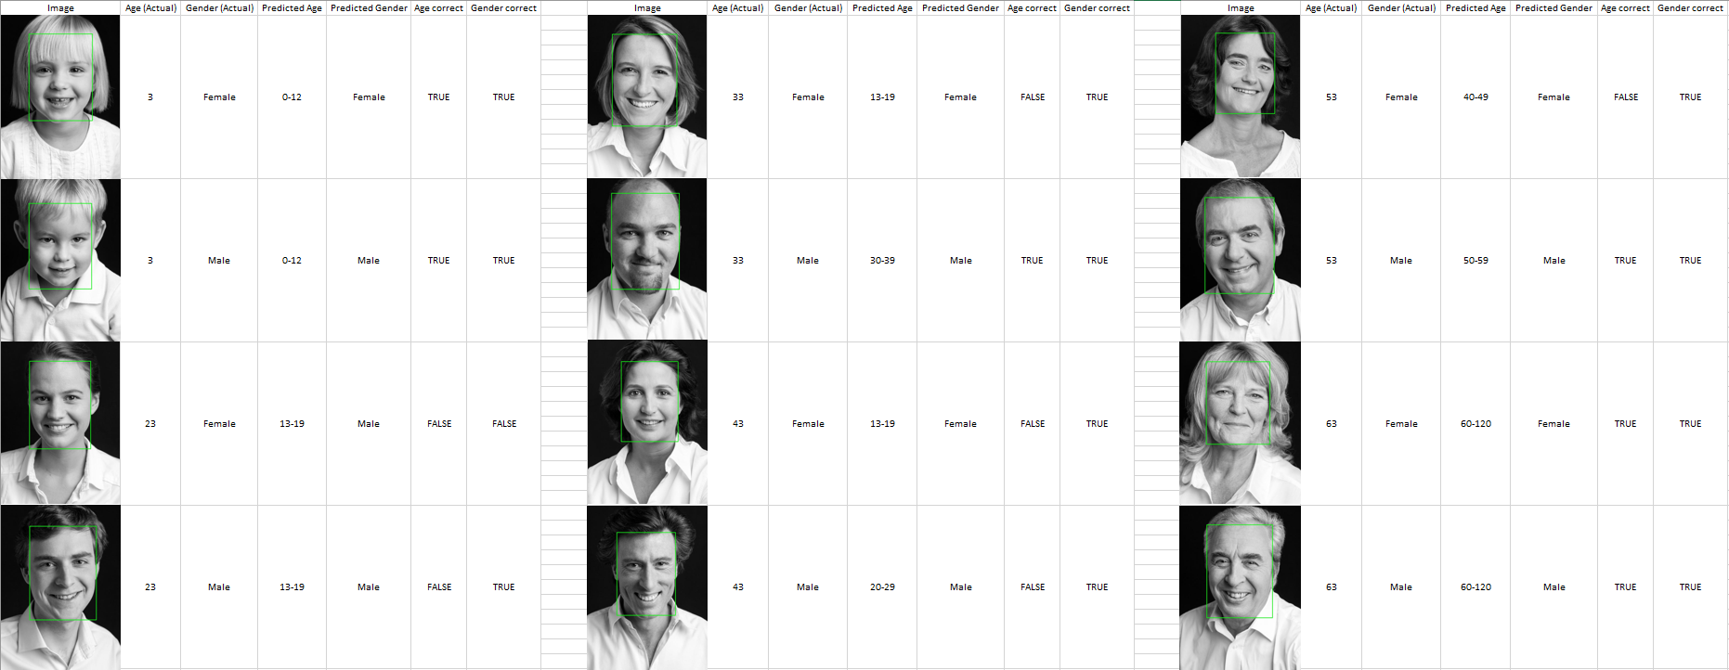
The screenshot of my experiments does not include samples of ages above 63, purely because all of them are correct. This is likely because there is still a huge gap between 60 and 120. I would recommend further separating the age class labels and investigating if it is possible to differentiate between age groups past 60yr. old as well. A 60yr. person can look vastly different from a 100yr. old.
As for speed, I did not look much into it, the system ran through my examples decently fast, so I have no complaints over that. The code looks well structured and well-documented. I liked the inclusion of system architecture diagrams, as they made understanding the process way easier. Overall, the assignment was implemented with care and attention to detail. Good work!

Final conclusion:
Based on given documentation of the project, it shows great potential and some room for performance and quality of life improvements. As a representative of a company, I would choose to invest in this project

